Monitor Learning Outcomes Workflow
- Pre-conditions :
  - The system shall have a facility to define the following references:
    - Types of Assessment is defined by the following data:
- Assessment Code (e.g. NAT, RAT, DAT, SReA (Readiness Assessment for Pre-school, PHIL-IRI (Reading Assessment))
- Competency Area (e.g. English, Science, Math, Reading)
- Grade/Year Level
- Level of Assessment (National/Central, Region, Division, District, School) – extent of assessment in terms of population and geographic area covered
    - Assessment Rubrics is defined by the following data:
- Type of Assessment
- Low Performing (e.g. MPS is less than 50% or raw score < 50)
- Average (e.g. MPS is between 51% to 70%)
- High Performing (e.g. MPS is 71% and above)
    - User/users responsible for entering and/or uploading assessment results by type of assessment. For example, the NETRC in the Central Office shall be responsible for uploading NAT results, while the Regional Offices shall be responsible for entering RAT results of schools within their respective regions; Bureau of Elem. Education (BEE) shall be responsible for uploading PHIL-IRI results in the system.
- Central Office user accesses the Monitor Learning Outcomes Main page through the BEIS.
  - The main page provides the following facilities, depending on the user’s rights as established in the system:
- Upload Assessment Results
- Enter Assessment Results
- View Assessment Results
- Generate Reports
  - Authorized user accesses the Upload Assessment Results
    - User provides the following data:
- Type of Assessment (drop-down list displays only the types of assessment the user is allowed to maintain)
- Grade/Year level
- School Year
- Data source (in a standard file format .xls; .csv; )
    - When Upload button is clicked, system checks if assessment records have already been created in the system for the given assessment type, grade/year level and school year. If record does not exist, upload proceeds, or system displays message “Assessment results already exist”.
    - Successful upload displays “Upload successfully finished… nnnnnn records have been created”
  - Authorized user accesses the Enter Assessment Results page.
    - User provides the following data:
- Type of Assessment (drop-down list displays only the types of assessment the user is allowed to maintain)
- Grade/Year level
- School Year
- Region – display drop-down list of regional offices from the DepED offices table
- Division –drop-down list of division offices from the DepED offices table, filtered by the specific region selected.
    - When Continue button is clicked, system checks whether the assessment results already exist.
      - If record exists, system displays summary record of assessment results, displaying the following data:
- Type of Assessment
- Grade/Year level
- School Year
- Region
- Division
- No. of records
    - If record does not exist, user enters assessment results for each school under the selected region and division and covering the given grade/year level. This data-entry of assessment results shall cover only subject areas provided for by the type of assessment. E.g. NAT covers only Math, English, Science and Filipino. SReA covers only Reading.
  - Authorized user accesses the View Assessments page.
    - User provides the following data:
- Type of Assessment (drop-down list displays only the types of assessment the user is allowed to maintain)
- Grade/Year level
- School Year
- Region – display drop-down list of regional offices from the DepED offices table
- Division –drop-down list of division offices from the DepED offices table, filtered by the specific region selected.
    - If region and/or division is not provided, system displays results at regional level
      - When specific region is clicked from the List generated, the system displays results by division.
      - When specific division is selected from the List generated, the system displays results by district.
      - When specific district office is selected from the List generated, the system displays results by school.
    - If a region is provided, system displays results at by division.
      - When specific division is selected from the List generated, the system displays results by district.
      - When specific district office is selected from the List generated, the system displays results by school.
    - The same process as 1.4.2 and 1.4.3 when data provided is at the level of division or district.
  - Authorized user accesses the Generate Reports page to automatically process the following reports/queries:
    - Trend Analysis of Learning Outcomes By Subject Area (filtered by region, division, district, school)
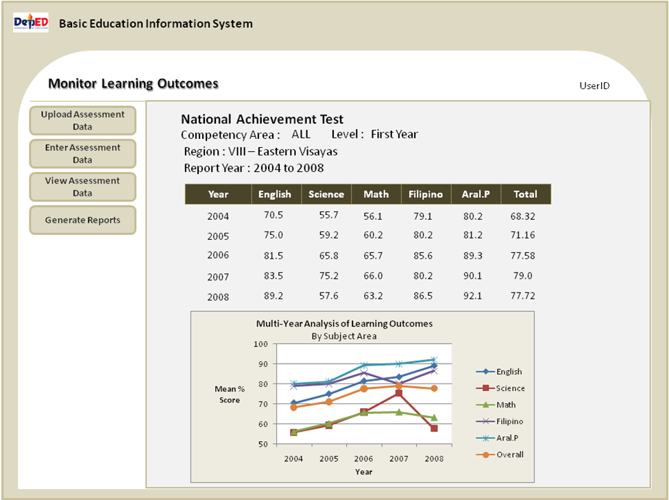

    - Summary of Learning Outcomes
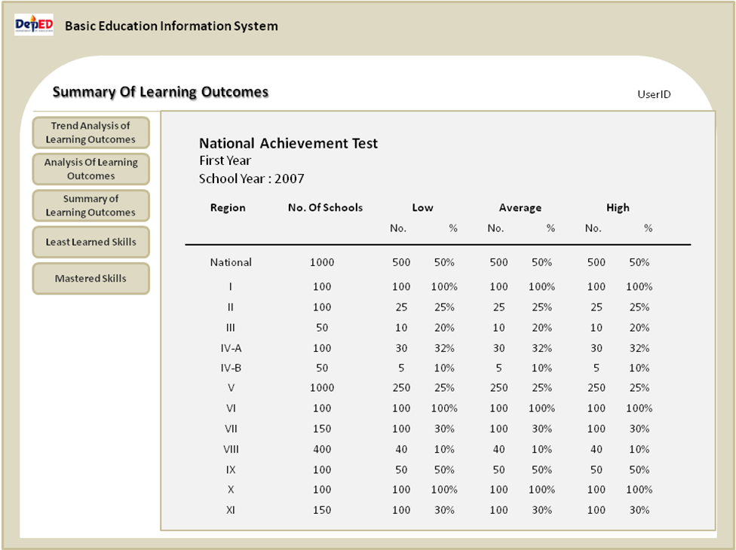

    - Report on Least Learned Skills
      - Provide for a facility to capture parameters/definition (in terms of MPS and/or raw score) for the following:
- low performing (e.g. MPS =< 50%)
- Average (e.g. MPS is between 50% and 70%)
- High Performing (e.g. MPS is >= 70%)
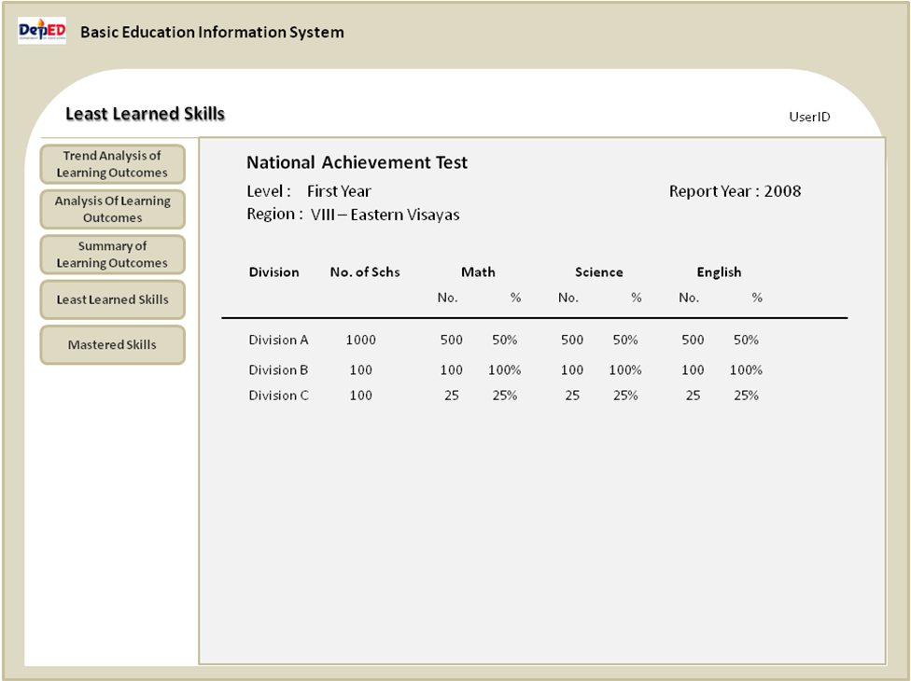
      - When No. (per subject area) is clicked, system displays all schools covering the no. selected.

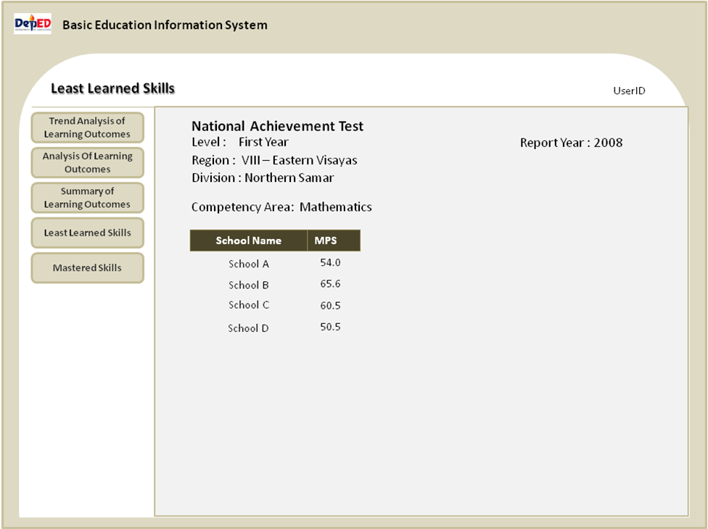

    - Report on Mastered Skills

The report is similar to 1.5.3 however using a different criteria. Schools selected are those whose MPS falls under the “High Performing” category.

- Regional Office user accesses the Monitor Learning Outcomes Main page through the BEIS.
  - The main page provides the following facilities, depending on the user’s rights as established in the system:
- Upload Assessment Results
- Enter Assessment Results
- View Assessment Results
- Generate Reports
  - Authorized user accesses the Upload Assessment Results
    - User provides the following data:
- Type of Assessment (drop-down list displays only the types of assessment the user is allowed to maintain)
- Grade/Year level
- School Year
- Data source (in a standard file format .xls; .csv; )
    - When Upload button is clicked, system checks if assessment records have already been created in the system for the given assessment type, grade/year level and school year. If record does not exist, upload proceeds, or system displays message “Assessment results already exist”.
    - Successful upload displays “Upload successfully finished… nnnnnn records have been created”
  - Authorized user accesses the Enter Assessment Results page.
    - User provides the following data:
- Type of Assessment (drop-down list displays only the types of assessment the user is allowed to maintain)
- Grade/Year level
- School Year
- Division –drop-down list of division offices from the DepED offices table, filtered by the specific region selected.
    - When Continue button is clicked, system checks whether the assessment results already exist.
      - If record exists, system displays summary record of assessment results, displaying the following data:
- Type of Assessment
- Grade/Year level
- School Year
- Division
- No. of records
    - If record does not exist, user enters assessment results for each school under the selected region and division and covering the given grade/year level. This data-entry of assessment results shall cover only subject areas provided for by the type of assessment. E.g. RAT covers only Math, English, Science and Filipino. SReA covers only Reading.
  - Authorized user accesses the View Assessments page.
    - User provides the following data:
- Type of Assessment (drop-down list displays only the types of assessment the user is allowed to maintain)
- Grade/Year level
- School Year
- Division –drop-down list of division offices from the DepED offices table, filtered by the specific region selected.
    - If division is not provided, system displays results at division level
      - When specific division is selected from the List generated, the system displays results by district.
      - When specific district office is selected from the List generated, the system displays results by school.
    - If a division is provided, system displays results by district .
      - When specific district is selected from the List generated, the system displays results by school .
  - Authorized user accesses the Generate Reports page to automatically process the following reports/queries:
    - Trend Analysis of Learning Outcomes By Subject Area (filtered by division, district, school)

    - Summary of Learning Outcomes

    - Report on Least Learned Skills
      - Provide for a facility to capture parameters/definition (in terms of MPS and/or raw score) for the following:
- low performing (e.g. MPS =< 50%)
- Average (e.g. MPS is between 50% and 70%)
- High Performing (e.g. MPS is >= 70%)

      - When No. (per subject area) is clicked, system displays all schools covering the no. selected.

    - Report in Mastered Skills

The report is similar to 1.5.3 however using a different criteria. Schools selected are those whose MPS falls under the “High Performing” category.

- Division Office user accesses the Monitor Learning Outcomes Main page through the BEIS.
  - The main page provides the following facilities, depending on the user’s rights as established in the system:
- Upload Assessment Results
- Enter Assessment Results
- View Assessment Results
- Generate Reports
  - Authorized user accesses the Upload Assessment Results
    - User provides the following data:
- Type of Assessment (drop-down list displays only the types of assessment the user is allowed to maintain)
- Grade/Year level
- School Year
- Data source (in a standard file format .xls; .csv; )
    - When Upload button is clicked, system checks if assessment records have already been created in the system for the given assessment type, grade/year level and school year. If record does not exist, upload proceeds, or system displays message “Assessment results already exist”.
    - Successful upload displays “Upload successfully finished… nnnnnn records have been created”
  - Authorized user accesses the Enter Assessment Results page.
    - User provides the following data:
- Type of Assessment (drop-down list displays only the types of assessment the user is allowed to maintain)
- Grade/Year level
- School Year
- District –drop-down list of district offices from the DepED offices table, filtered by the specific district selected.
    - When Continue button is clicked, system checks whether the assessment results already exist.
      - If record exists, system displays summary record of assessment results, displaying the following data:
- Type of Assessment
- Grade/Year level
- School Year
- District
- No. of records
    - If record does not exist, user enters assessment results for each school under the selected region and division and covering the given grade/year level. This data-entry of assessment results shall cover only subject areas provided for by the type of assessment. E.g. RAT covers only Math, English, Science and Filipino. SReA covers only Reading.
  - Authorized user accesses the View Assessments page.
    - User provides the following data:
- Type of Assessment (drop-down list displays only the types of assessment the user is allowed to maintain)
- Grade/Year level
- School Year
- District –drop-down list of division offices from the DepED offices table, filtered by the specific region selected.
    - If district is not provided, system displays results at district level
      - When specific district is selected from the List generated, the system displays results by school .
    - If a district is provided, system displays results by school .
      - When specific district is selected from the List generated, the system displays results by school .
  - Authorized user accesses the Generate Reports page to automatically process the following reports/queries:
    - Trend Analysis of Learning Outcomes By Subject Area (district, school)

    - Summary of Learning Outcomes

    - Report on Least Learned Skills
      - Provide for a facility to capture parameters/definition (in terms of MPS and/or raw score) for the following:
- low performing (e.g. MPS =< 50%)
- Average (e.g. MPS is between 50% and 70%)
- High Performing (e.g. MPS is >= 70%)

      - When No. (per subject area) is clicked, system displays all schools covering the no. selected.

    - Report in Mastered Skills

The report is similar to 1.5.3 however using a different criteria. Schools selected are those whose MPS falls under the “High Performing” category.

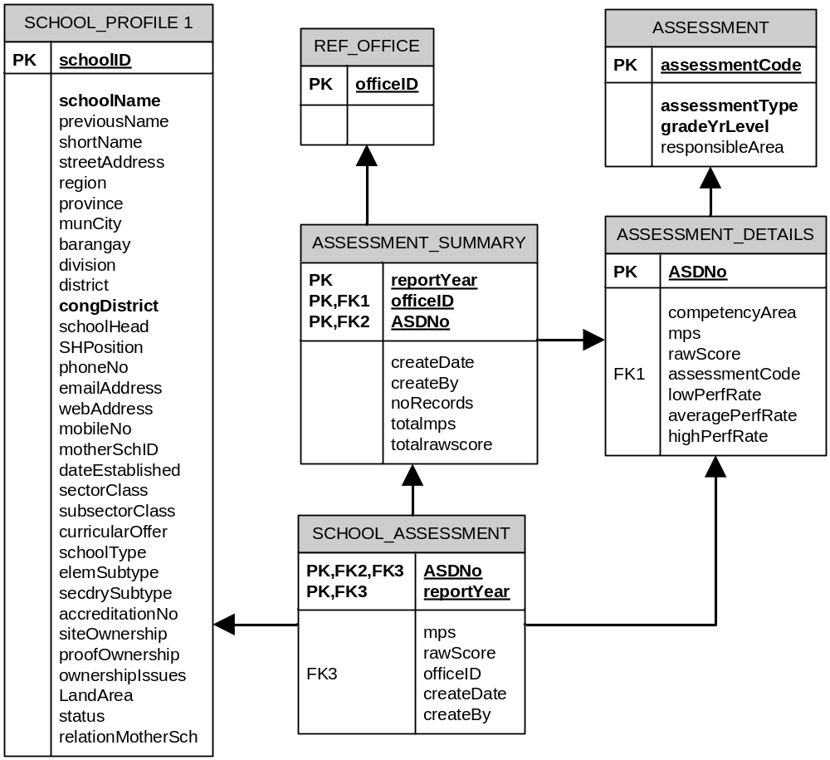

TABLE NAME | ASSESSMENT
DESCRIPTION: | Record of different types of assessment of learning outcomes being undertaken at all levels
Field Name | Description |  | Format | Constraint
assessment Code | Record unique identifier |  | Integer (6)
assessmentType | Type of assessment (e.g. NAT, DAT, RAT, SREA, etc) |  | Varchar (5) | Linked to ref_code and ref_code_settings
gradeYrLevel | Grade and year level being assessed |  | Char(2) | Linked to ref_code and ref_code_settings
responsibleArea | Deped level responsible for generating and entering data into the system |  | Varchar(5) | Linked to deped offices and ref_users
TABLE NAME | ASSESSMENT_DETAILS
DESCRIPTION: | Details of assessment type includes the competencies/subject areas covered and the performance rubrics for low performing, average and high performing
Field Name | Description |  | Format | Constraint
ASDNo | Record unique identifier |  | Integer(6)
competencyArea | Competencies/subject areas covered by the type of assessment |  | Varchar(10) | Linked to ref_code and ref_code_settings
mps | Indicates that scoring is by Mean percentage score |  |  | Null or 1
rawScore | Indicates that scoring is by raw score |  |  | Null or 1
assessmentCode | Assessment code
lowPerfRate | Maximum rate defining low performance (e.g. 50% indicates that scores equal to or less that 50% are categorized as low performing
averagePerfRate | Maximum rate defining average performance (e.g. 69% indicates that scores between lowPerfRate and less than or equal to averagePerfRate are categorized as average performing
highPerfRate | Maximum rate defining average performance (e.g. 69% indicates that scores between lowPerfRate and less than or equal to averagePerfRate are categorized as average performing
TABLE NAME | ASSESSMENT_SUMMARY
DESCRIPTION: | Summary of assessment results by deped region, division, district
Field Name | Description |  | Format | Constraint
officeID | Deped office identifier |  |  | Linked to ref_office
reportYear | School year covered by the assessment
ASDNo | Reference to competencies/subject areas in the assessment details table |  |  | Linked to assessment_ details
totalmps | Average mean percentage score of all schools covered under the deped office
totalscore | Average raw score of all schools covered under the deped office
createDate | Date assessment results were entered
createBy | User
TABLE NAME | SCHOOL_ASSESSMENT
DESCRIPTION: | Record assessment results by school and type of assessment.
Field Name | Description |  | Format | Constraint
schoolID | Record unique identifier
reportYear | School year covered by the assessment
mps | Grade and year level being assessed
rawScore | Deped level responsible for generating and entering data into the system
assmtSmryNo | Reference to assessment summary table

